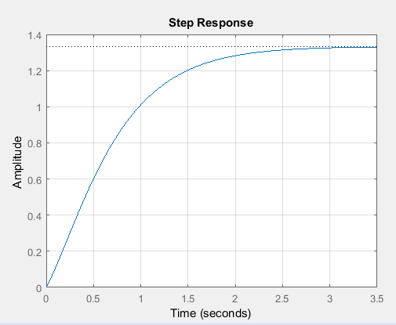
Exercise 1(a)

A = [0 1; -6 -5];
B = [0; 1];
C =[8 1];
D =[0];

[num,den] = ss2tf(A,B,C,D);
sys =tf(num,den);
step(sys);
grid on;

Exercise 1(b)

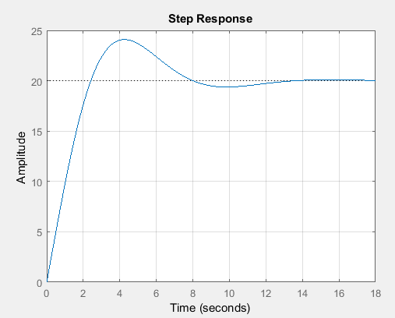

A = [0 1 0;0 0 1;-1 -2 -3];
B = [10;0;0];
C =[1 0 0];
D =[0];

[num,den] = ss2tf(A,B,C,D);
sys =tf(num,den);
step(sys);
grid on;

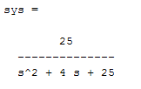
Exercise 2
num =[0 0 25];
den =[1 4 25];
sys = tf(num ,den)

Exercise 3
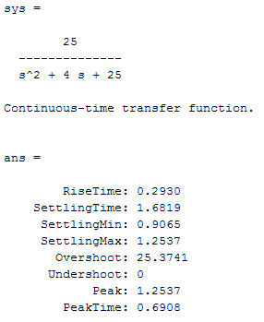
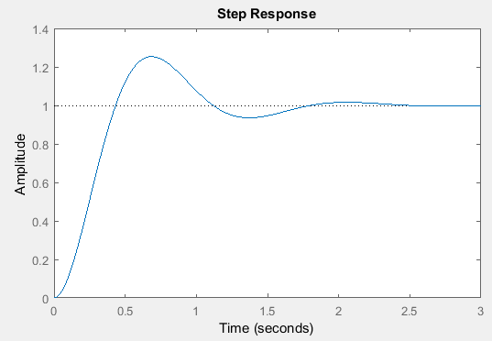

num =[0 0 25];
den =[1 4 25];
sys = tf(num ,den)

ltiview(sys)
stepinfo(sys)

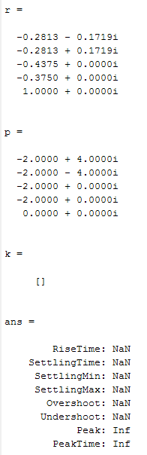
Exercise 4
num =[3 25 72 80];
den =[1 8 40 96 80 0];
t = 0:0.01:10;
sys = tf(num ,den)
c_t = step(sys,t)
plot(t,c_t)
[r,p,k]=residue(num,den)
ltiview(sys)
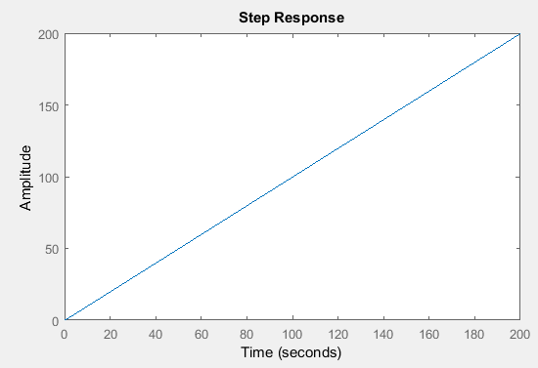
stepinfo(sys)

Exercise 5
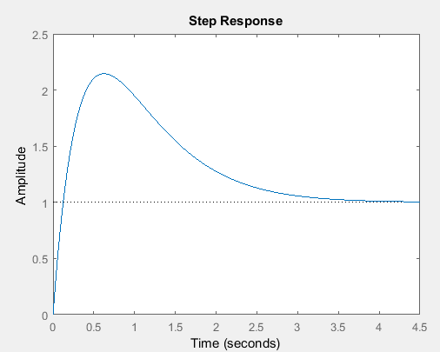
num =[0 10 4];
den =[1 4 4];
sys = tf(num ,den)
figure;
step(sys)
title('Step Response')

num2 =[0 10 4];
den2 =[1 4 4 0];
sys2 = tf(num2 ,den2)
figure;
step(sys2)
title('Ramp Response')

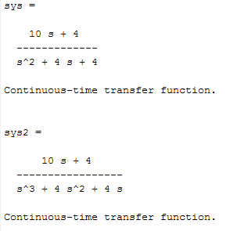

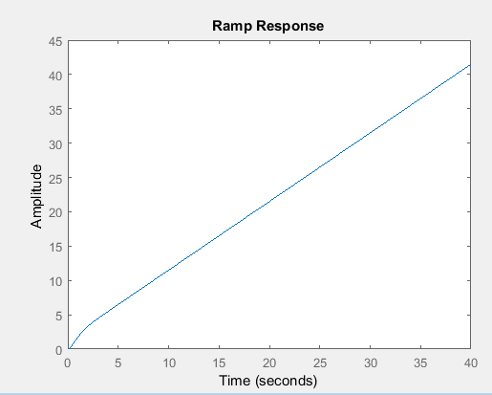

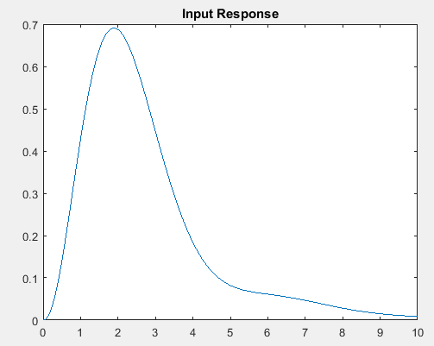
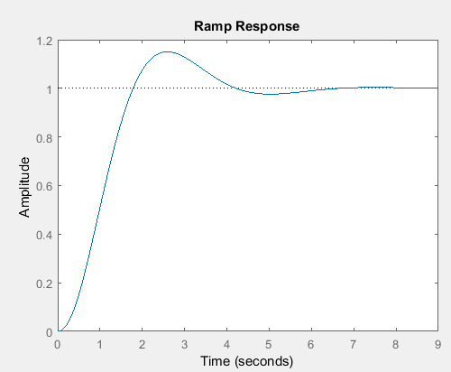
Exercise 6
num =[0 1 10];
den =[1 6 9 10];
sys = tf(num ,den)
figure;
step(sys)
title('Ramp Response')

t = 0:0.01:10;
r_t=exp(-0.5*t);
y=lsim(sys,r_t,t);
figure;
plot(t,y)
title('Input Response')

Exercise 7
num =[0 0 16];
den =[1 4 16];
sys = tf(num ,den)
step(sys,t)

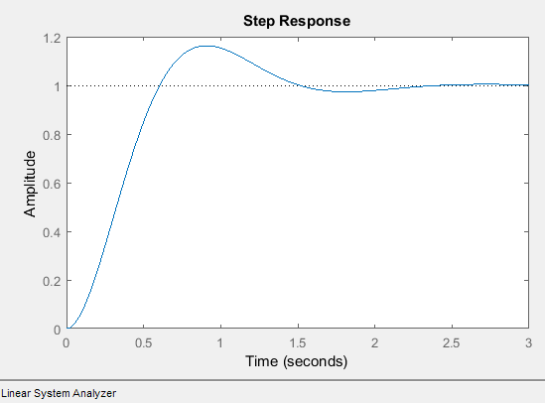
ltiview(sys)
stepinfo(sys)

